Arduino Gyro-Controlled Robot Car
Complete Technical Report
MPU-9250 Gyroscope | L298N Motor Driver | Arduino Uno
June 2025 | Embedded Systems Project
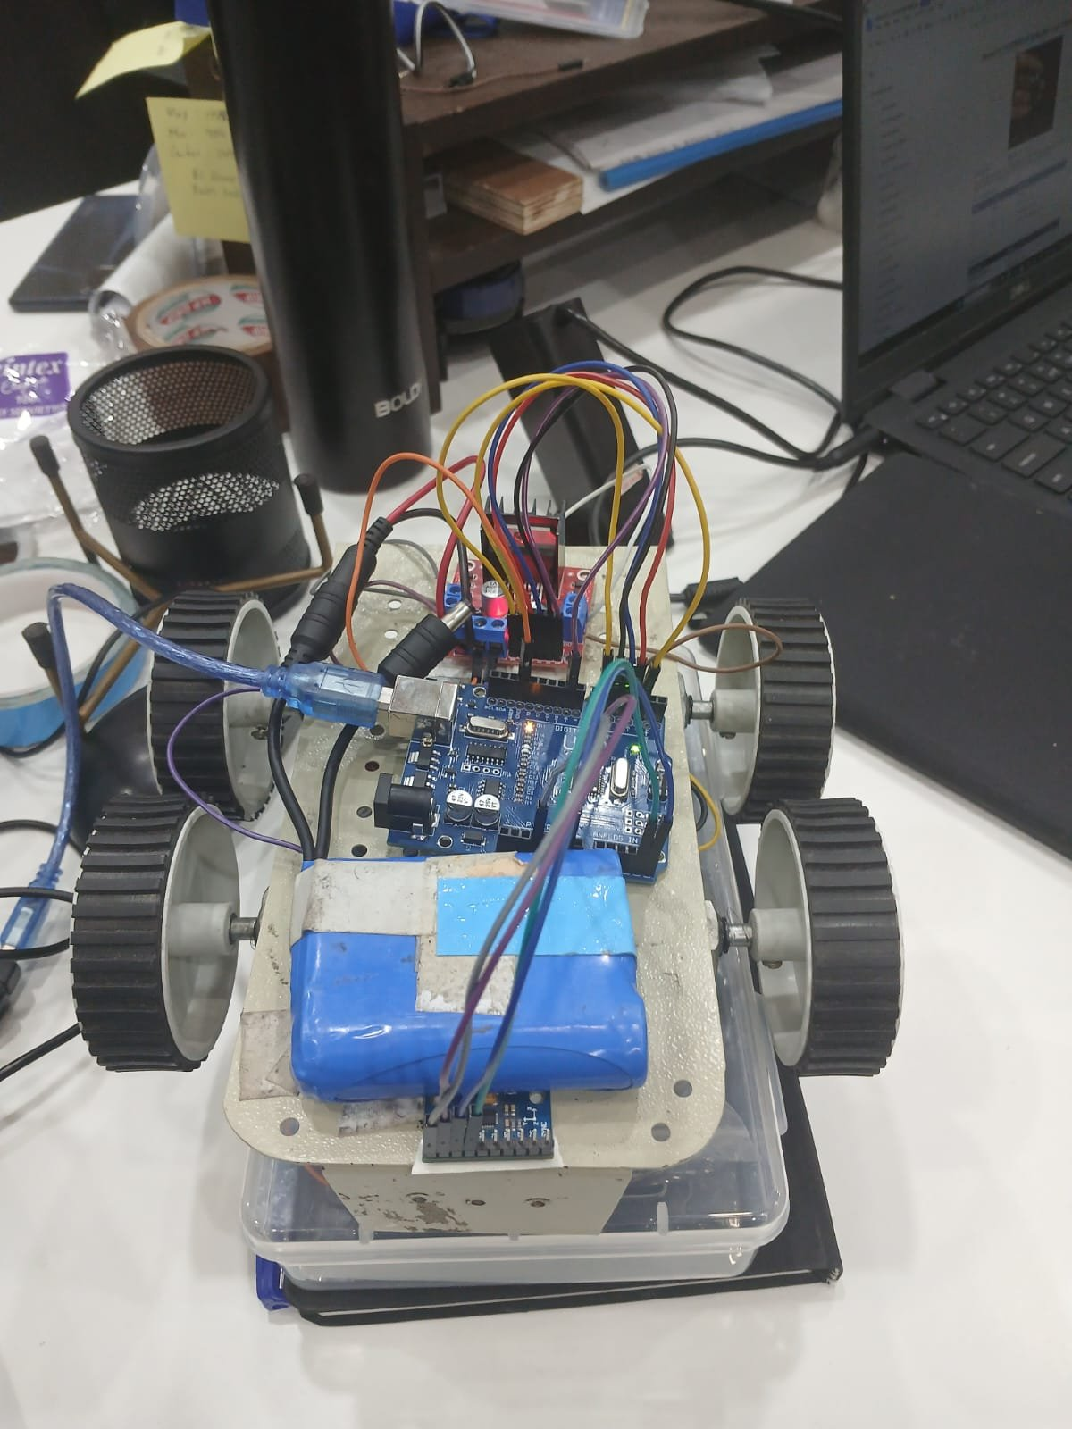
Figure 1 — Assembled robot car: Arduino Uno, L298N driver, GY-9250 IMU, Li-ion battery pack, 4-wheel chassis

Table of Contents
1. Project Overview
2. Hardware Components
3. Module & Build Photos
4. Module Identification (GY-9250 Board)
5. Wiring Diagram
6. Pin Configuration
7. Firmware Architecture
8. Motor Control Logic
9. Turn Control Algorithm
10. Known Bugs & Problems
11. Recommended Fixes
12. Complete Source Code
13. Function Reference
14. Conclusion

1. Project Overview
This project implements a serial-command-driven robot car using an Arduino Uno microcontroller, an MPU-9250 9-axis IMU (Z-axis gyroscope only), and an L298N dual H-bridge motor driver. The firmware enables precise, angle-controlled turns using real-time gyroscope integration, along with basic forward and stop commands over USB serial at 9600 baud.

2. Hardware Components
Component | Model | Role
Microcontroller | Arduino Uno | Main control logic, serial comms, PWM generation
IMU Sensor | MPU-9250 on GY-9250 board (I2C 0x68) | Z-axis gyroscope for yaw measurement & closed-loop turns
Motor Driver | L298N Dual H-Bridge | Drives 2 DC motors — direction + PWM speed
DC Motors | 4x DC Geared Motors | Differential drive: forward and in-place turns
Battery | Li-ion 18650 cells (visible in photos) | Motor power supply (~7.4V from 2S pack)
Chassis | 4-wheel plastic platform | Structural base with motor mounts

3. Module & Build Photos
3.1 Assembled Robot — Top View
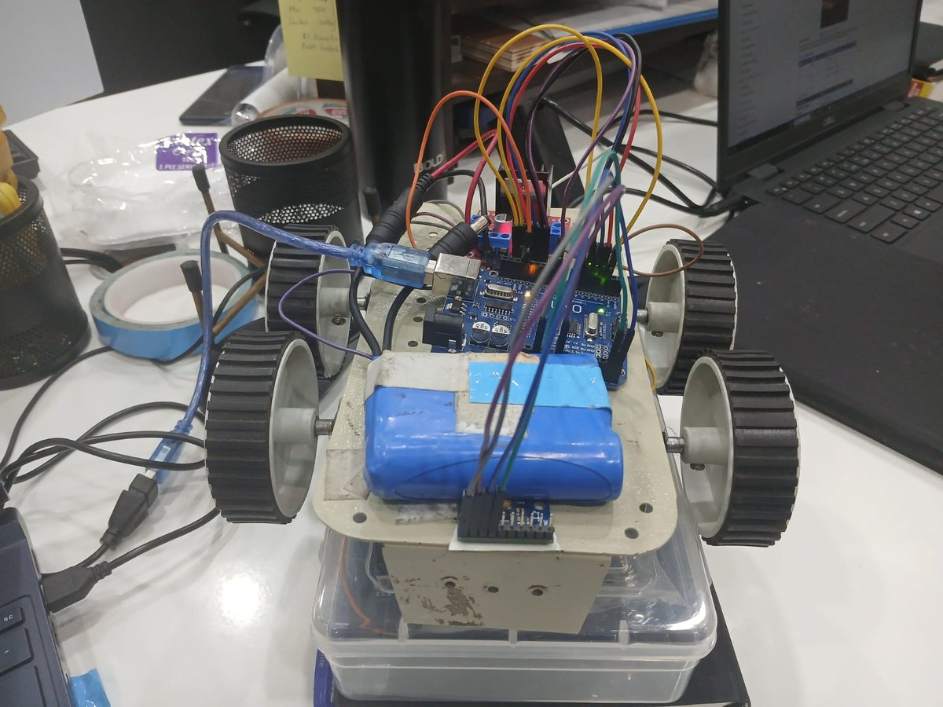
Figure 2 — Top view showing Arduino Uno (blue, centre-left), L298N driver (red board, top), GY-9250 IMU (bottom edge), coloured wiring harness, and Li-ion battery pack taped to chassis

3.2 GY-9250 MPU-9250 Module — Three Views
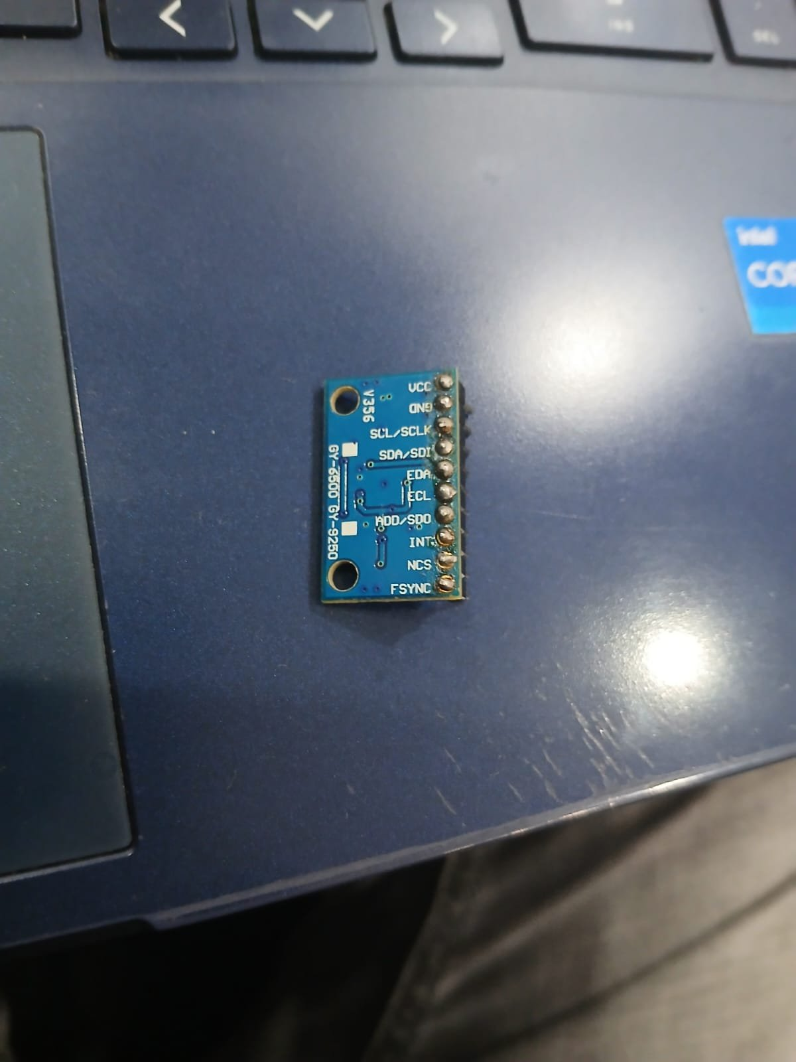 | 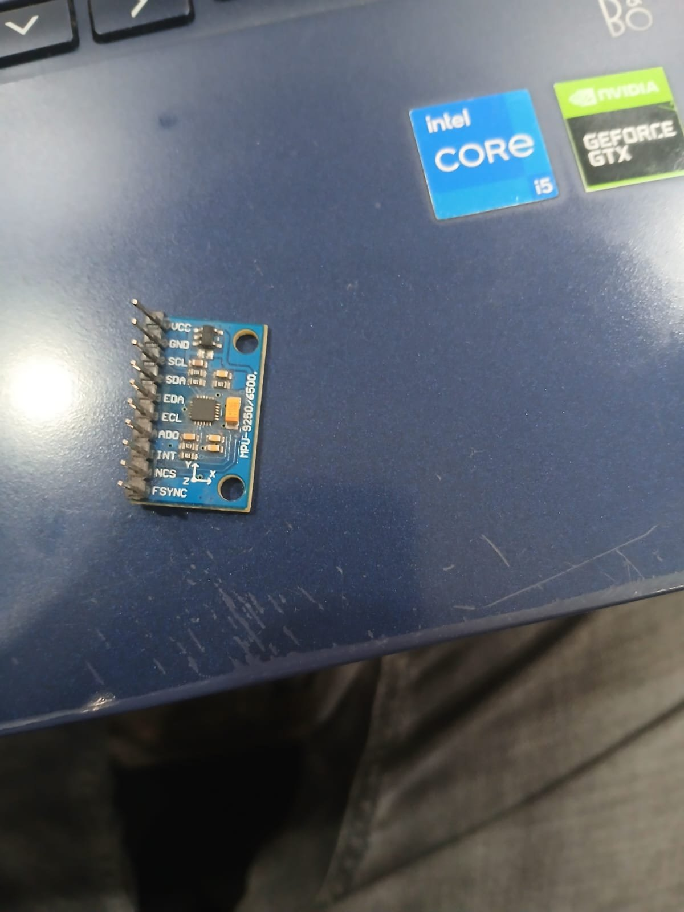

Figure 3 (left) — Back side showing 10-pin header labels Figure 4 (right) — Front side showing MPU-9250 IC and SMD components

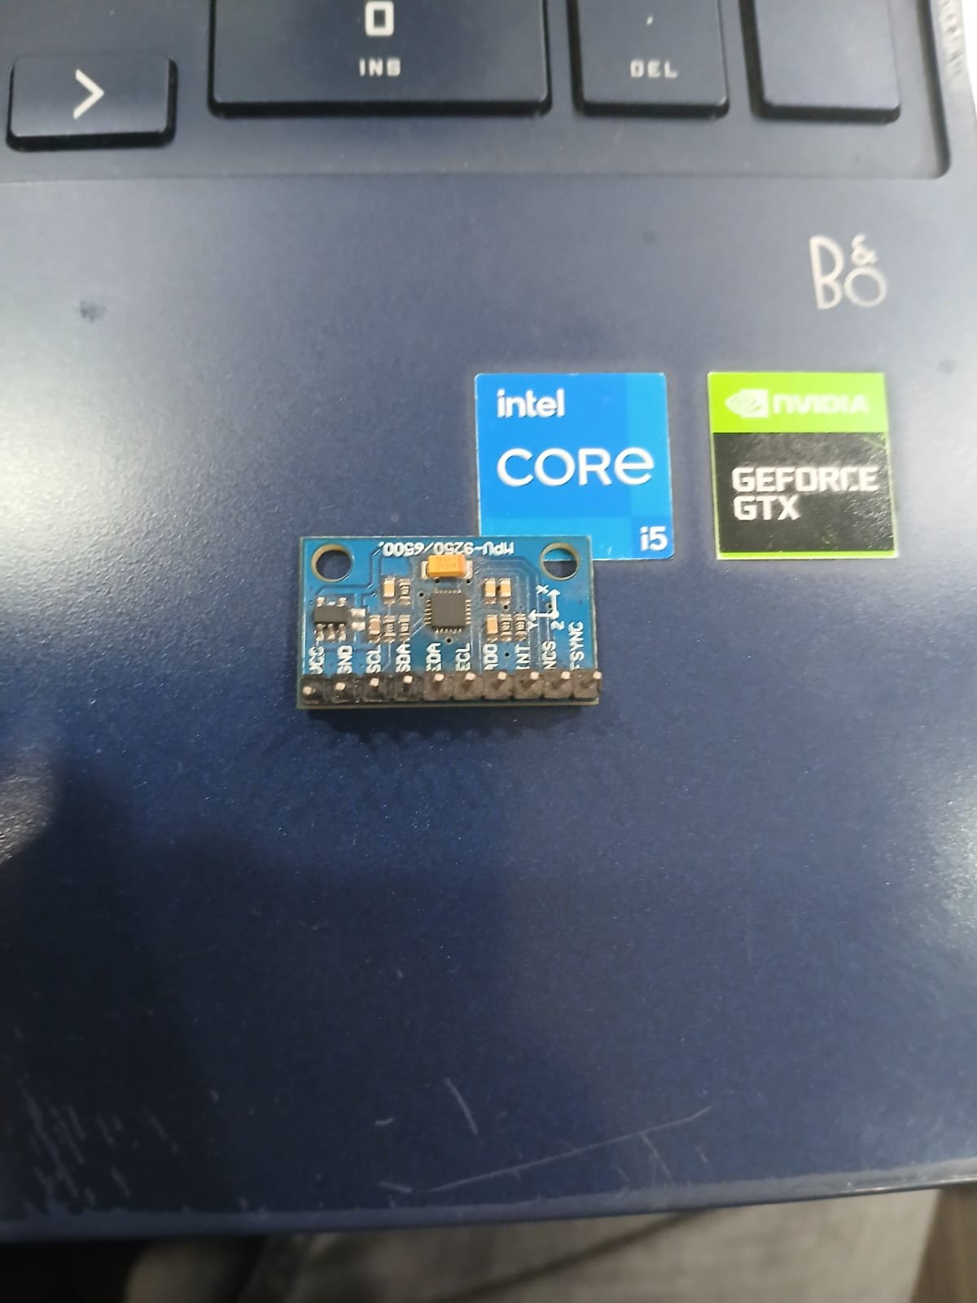
Figure 5 — Bottom view of GY-9250 board showing all 10 pins soldered

4. Module Identification (GY-9250 Board)
The photos confirm a GY-9250 / GY-6500 breakout board carrying the InvenSense MPU-9250. It integrates a 3-axis MEMS gyroscope, 3-axis accelerometer, and 3-axis magnetometer (AK8963). Only the Z-axis gyroscope is used in this project. The board has 10 through-hole header pins.

Pin on Board | Function | Usage in This Project
VCC | Power supply | Connect to Arduino 3.3V ONLY — NEVER 5V
GND | Ground | Connect to Arduino GND
SCL / SCLK | I2C Clock / SPI Clock | Connect to Arduino A5
SDA / SDI | I2C Data / SPI MOSI | Connect to Arduino A4
EDA | Aux I2C Data (magnetometer) | Not connected (NC)
ECL | Aux I2C Clock (magnetometer) | Not connected (NC)
ADO / SDO | I2C address bit / SPI MISO | Tie to GND → address 0x68
INT | Interrupt output | Optional — connect to Arduino D2
NCS | SPI Chip Select | NC — board in I2C mode
FSYNC | Frame Sync | Not connected (NC)

NOTE: The MPU-9250 is a 3.3V device. Applying 5V to VCC permanently destroys the chip. Verify whether your GY-9250 variant has an onboard voltage regulator before powering.

5. Wiring Diagram
5.1 MPU-9250 to Arduino
MPU-9250 (GY-9250 Board) Arduino Uno
+----------------+ +------------------+
| VCC ----------+-----------> | 3.3V (NOT 5V!) |
| GND ----------+-----------> | GND |
| SCL ----------+-----------> | A5 (SCL) |
| SDA ----------+-----------> | A4 (SDA) |
| ADO --[GND tie] | (sets addr 0x68) |
| INT ----------+-----------> | (optional) D2 |
| EDA,ECL,NCS,FSYNC -- NC | |
+----------------+ +------------------+

5.2 L298N to Arduino & Motors
L298N Motor Driver Arduino Uno
+----------------+ +------------------+
| IN1 ----------+-----------> | D2 |
| IN2 ----------+-----------> | D3 |
| IN3 ----------+-----------> | D4 |
| IN4 ----------+-----------> | D5 |
| ENA ----------+-----------> | D6 (PWM~) |
| ENB ----------+-----------> | D9 (PWM~) |
| GND ----------+-----------> | GND (common) |
| +5V ----------+-----------> | 5V (logic) |
| +12V <--- Battery (7-12V) | |
| OUT1 ---> Motor A (+) | |
| OUT2 ---> Motor A (-) | |
| OUT3 ---> Motor B (+) | |
| OUT4 ---> Motor B (-) | |
+----------------+ +------------------+

5.3 Wiring Notes
- MPU-9250 VCC → Arduino 3.3V pin (NOT 5V — chip will be destroyed).
- ADO tied to GND sets I2C address 0x68, matching #define MPU_ADDR 0x68 in code.
- Add 100 nF ceramic decoupling capacitor between MPU VCC and GND close to the chip.
- Arduino and L298N must share a common GND even if powered separately.
- Li-ion 2S pack (~7.4V) connects to L298N +12V terminal for motor power.

6. Pin Configuration
Arduino Pin | Direction | Label | Connected To | Function
A4 (SDA) | Bidirectional | SDA | MPU-9250 SDA | I2C data line
A5 (SCL) | Output | SCL | MPU-9250 SCL | I2C clock line
D2 | Output | IN1 | L298N IN1 | Motor A direction bit 1
D3 | Output | IN2 | L298N IN2 | Motor A direction bit 2
D4 | Output | IN3 | L298N IN3 | Motor B direction bit 1
D5 | Output | IN4 | L298N IN4 | Motor B direction bit 2
D6 (PWM~) | Output | ENA | L298N ENA | Motor A speed control
D9 (PWM~) | Output | ENB | L298N ENB | Motor B speed control

7. Firmware Architecture
7.1 Startup Sequence
- Serial + I2C initialised at 9600 baud.
- Motor driver pins set OUTPUT; motors stopped.
- MPU-9250 woken: register 0x6B written with 0x00.
- calibrateGyro(): 500 samples at ~200 Hz → compute gyroOffset.
- prevTime latched; 'READY' printed.

7.2 Gyroscope Calibration
500 raw Z-axis readings averaged to compute static bias offset, removing sensor zero-rate error.
for (int i=0; i<500; i++) { sum += readGyroZ(); delay(5); }
gyroOffset = sum / 500.0;

7.3 Yaw Integration
Every loop: read raw gyro Z, subtract offset, convert to deg/s (131 LSB/deg/s at default +/-250 deg/s range), integrate over dt.
float gyroZ = (readGyroZ() - gyroOffset) / 131.0; // deg/s
yaw += gyroZ * dt; // degrees

7.4 Serial Commands
Command | Example | Physical Result | Note
F | F | Both motors forward at PWM 180 | Runs until 'S' sent
S | S | All motors stop (coast) | Works except during blocking turn
L<angle> | L90 | Car turns RIGHT 90° | BUG: L physically goes right
R<angle> | R45 | Car turns LEFT 45° | BUG: R physically goes left

8. Motor Control Logic
State | IN1 | IN2 | IN3 | IN4 | Motor A | Motor B | PWM
Forward | HIGH | LOW | HIGH | LOW | Forward | Forward | 180
Spin Right | HIGH | LOW | LOW | HIGH | Forward | Reverse | 160
Spin Left | LOW | HIGH | HIGH | LOW | Reverse | Forward | 160
Stop | LOW | LOW | LOW | LOW | Coast | Coast | 0

9. Turn Control Algorithm
Turns use a closed-loop bang-bang controller: spin at full TURN_SPEED and stop when integrated yaw delta meets the target angle.
- Record startYaw.
- Engage spin direction.
- Loop: updateYaw() each iteration, compare delta to target.
- When delta >= target, stopCar().

NOTE: Bang-bang control causes overshoot of 5-15 degrees due to motor inertia after stopCar(). A PID or ramp-down zone would improve accuracy.

10. Known Bugs & Problems

Bug 1 — L/R Command Labels Swapped (Critical)
BUG: Sending 'L45' physically turns RIGHT. Sending 'R45' turns LEFT. Labels are inverted throughout loop(), turnRight(), and turnLeft(). Serial confirmation messages are also wrong.
FIX: In loop(): swap calls so 'L' calls turnLeft() and 'R' calls turnRight(). Fix Serial.println strings inside each function.

Bug 2 — Blocking Turn Loop Freezes Serial (High)
BUG: The while-loop inside turn functions blocks loop(). No serial commands processed during a turn. Sending 'S' mid-turn has no effect. Gyro failure causes infinite spin.
FIX: Refactor to a non-blocking state machine: enum {IDLE, TURNING_LEFT, TURNING_RIGHT, FORWARD}. Check yaw progress inside loop() each iteration.

Bug 3 — Yaw Drift Over Time (High)
BUG: Integration accumulates floating-point error plus residual noise. Yaw diverges from true heading over multiple turns with no correction.
FIX: Add 'Z' command to reset yaw. Long term: implement complementary filter fusing gyroscope and accelerometer.

Bug 4 — Turn Overshoot (Medium)
BUG: Motor runs at full TURN_SPEED (PWM 160) until target, then stops abruptly. Inertia carries robot 5-15 degrees past target.
FIX: Add deceleration zone: when (target - delta) < 15 degrees, reduce PWM to ~80 before stopping.

Bug 5 — No Emergency Stop During Turn (Medium)
BUG: Blocking turn loop has no timeout. Sensor failure causes indefinite spin, unresponsive to serial.
FIX: Add watchdog: if turn exceeds (angle / minDegPerSec * 3) ms, force stopCar() and print error.

Bug 6 — 5V Risk to MPU-9250 (Critical Hardware)
BUG: MPU-9250 is 3.3V. Connecting VCC to Arduino 5V pin permanently destroys the sensor instantly.
FIX: Always connect MPU-9250 VCC to Arduino 3.3V. Verify your GY-9250 board variant for onboard regulator.

Bug 7 — Hardcoded Sensitivity Divisor 131.0 (Low)
BUG: If gyro full-scale range is changed (register 0x1B), divisor 131.0 becomes wrong and all angles are incorrect.
FIX: Define: #define GYRO_SENSITIVITY 131.0 and add a comment linking to register 0x1B.

11. Recommended Fixes Summary
Priority | Fix | Effort
CRITICAL | Fix L/R label inversion in loop() and Serial messages | 5 min
CRITICAL | Use 3.3V for MPU-9250 VCC — not 5V | Hardware
HIGH | Add turn timeout watchdog | 30 min
HIGH | Replace blocking turn with state machine | 2-3 hrs
MEDIUM | Add deceleration zone to reduce overshoot | 1 hr
MEDIUM | Add 'Z' yaw-reset command | 10 min
LOW | Define GYRO_SENSITIVITY constant | 5 min
ADVANCED | Complementary filter for long-term accuracy | 4-6 hrs

12. Complete Source Code
Full firmware as provided, with inline bug annotations. Bugs marked with // BUG: comments.

#include <Wire.h>

// ===== MPU9250 (gyro only) =====
#define MPU_ADDR 0x68

// ===== L298N =====
#define IN1 2
#define IN2 3
#define IN3 4
#define IN4 5
#define ENA 6
#define ENB 9

int FWD_SPEED = 180;
int TURN_SPEED = 160;

// ===== Yaw Tracking =====
float yaw = 0;
float gyroOffset = 0;
unsigned long prevTime;

void setup() {
Serial.begin(9600);
Wire.begin();
pinMode(IN1,OUTPUT); pinMode(IN2,OUTPUT);
pinMode(IN3,OUTPUT); pinMode(IN4,OUTPUT);
pinMode(ENA,OUTPUT); pinMode(ENB,OUTPUT);
stopCar();
Wire.beginTransmission(MPU_ADDR);
Wire.write(0x6B); Wire.write(0);
Wire.endTransmission(true);
Serial.println("Calibrating Gyro...");
calibrateGyro();
prevTime = millis();
Serial.println("READY");
}

void loop() {
updateYaw();
if (Serial.available()) {
String cmd = Serial.readStringUntil('\n');
cmd.trim();
if (cmd == "F") forwardCar();
else if (cmd == "S") stopCar();
// BUG: L calls turnRight, R calls turnLeft (labels swapped)
else if (cmd.startsWith("L")) { float a=cmd.substring(1).toFloat(); if(a>0) turnRight(a); }
else if (cmd.startsWith("R")) { float a=cmd.substring(1).toFloat(); if(a>0) turnLeft(a); }
}
}

void calibrateGyro() {
long sum = 0;
for (int i=0; i<500; i++) { sum += readGyroZ(); delay(5); }
gyroOffset = sum / 500.0;
Serial.print("Gyro Offset = "); Serial.println(gyroOffset);
}

int16_t readGyroZ() {
Wire.beginTransmission(MPU_ADDR);
Wire.write(0x47);
Wire.endTransmission(false);
Wire.requestFrom(MPU_ADDR, 2, true);
return (Wire.read() << 8) | Wire.read();
}

void updateYaw() {
unsigned long now = millis();
float dt = (now - prevTime) / 1000.0;
prevTime = now;
float gyroZ = (readGyroZ() - gyroOffset) / 131.0;
yaw += gyroZ * dt;
}

// BUG: called by 'L' command but physically turns RIGHT
void turnRight(float angle) {
float startYaw = yaw; spinRight();
while ((yaw - startYaw) < angle) {
updateYaw();
Serial.print("Yaw="); Serial.println(yaw - startYaw);
}
stopCar();
Serial.println("LEFT TURN COMPLETE"); // BUG: wrong message
}

// BUG: called by 'R' command but physically turns LEFT
void turnLeft(float angle) {
float startYaw = yaw; spinLeft();
while ((startYaw - yaw) < angle) {
updateYaw();
Serial.print("Yaw="); Serial.println(startYaw - yaw);
}
stopCar();
Serial.println("RIGHT TURN COMPLETE"); // BUG: wrong message
}

void forwardCar() {
digitalWrite(IN1,HIGH); digitalWrite(IN2,LOW);
digitalWrite(IN3,HIGH); digitalWrite(IN4,LOW);
analogWrite(ENA,FWD_SPEED); analogWrite(ENB,FWD_SPEED);
}
void spinRight() {
digitalWrite(IN1,HIGH); digitalWrite(IN2,LOW);
digitalWrite(IN3,LOW); digitalWrite(IN4,HIGH);
analogWrite(ENA,TURN_SPEED); analogWrite(ENB,TURN_SPEED);
}
void spinLeft() {
digitalWrite(IN1,LOW); digitalWrite(IN2,HIGH);
digitalWrite(IN3,HIGH); digitalWrite(IN4,LOW);
analogWrite(ENA,TURN_SPEED); analogWrite(ENB,TURN_SPEED);
}
void stopCar() {
digitalWrite(IN1,LOW); digitalWrite(IN2,LOW);
digitalWrite(IN3,LOW); digitalWrite(IN4,LOW);
analogWrite(ENA,0); analogWrite(ENB,0);
}

13. Function Reference
Function | Returns | Description
setup() | void | Init pins, wake IMU, calibrate gyro, set prevTime
loop() | void | Run updateYaw() every cycle; parse & dispatch serial commands
calibrateGyro() | void | Average 500 samples → compute static gyro bias (gyroOffset)
readGyroZ() | int16_t | Read 2 bytes from IMU register 0x47; return signed 16-bit Z rate
updateYaw() | void | Integrate corrected gyroZ over dt into global yaw variable
turnRight(float) | void | BLOCKING: spin right until yaw delta >= angle (called by 'L' — BUG)
turnLeft(float) | void | BLOCKING: spin left until yaw delta >= angle (called by 'R' — BUG)
forwardCar() | void | Both motors forward at FWD_SPEED (PWM 180)
spinRight() | void | Motor A forward, Motor B reverse at TURN_SPEED (PWM 160)
spinLeft() | void | Motor A reverse, Motor B forward at TURN_SPEED (PWM 160)
stopCar() | void | All IN pins LOW, PWM = 0 — coast stop

14. Conclusion
The firmware delivers a functional baseline for gyroscope-assisted differential-drive navigation using the GY-9250 MPU-9250 module visible in the build photos. The MPU-9250 Z-axis integration provides adequate turn accuracy for short manoeuvres (approximately ±5-10 degrees for a 90-degree turn), though precision degrades over multiple turns due to gyro drift.

The most urgent issues are the L/R command label inversion (causing opposite-direction turns) and the 5V wiring risk (which can instantly destroy the MPU-9250 sensor). The blocking turn loop should be refactored into a state machine for any production application.

With these corrections applied, the platform — as seen in the photos with its 4-wheel chassis and Li-ion battery pack — is well-suited for autonomous path following, maze solving, or remote teleoperation projects.

